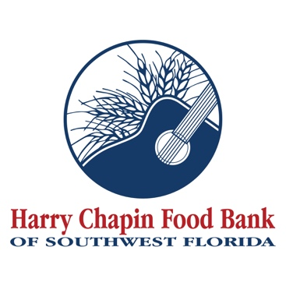

FOR IMMEDIATE RELEASE
DOWNLOAD LINK: Hunger Action Center Media Kit (renderings, project details)

Harry Chapin Food Bank receives $500K grant from Florida Blue
Funding to address food insecurity through new Hunger Action Center
FORT MYERS, Fla. (DATE, 2026) – The Florida Blue Foundation donated $500,000 to Harry Chapin Food Bank’s Feeding the Future capital campaign to support construction of the nonprofit’s new Hunger Action Center.
The 110,175-square-foot warehouse and distribution facility is currently under development at the southwest corner of I-75 and Dr. Martin Luther King Jr. Blvd. in Fort Myers. Once completed in late 2026, the Hunger Action Center will double the Food Bank’s capacity to feed neighbors experiencing hunger.
“This generous grant from Florida Blue pushes our capital campaign closer to its $30 million goal and pushes our mission of ending hunger closer to reality,” said Richard LeBer, president and CEO of Harry Chapin Food Bank. “The hunger crisis continues to worsen in Southwest Florida, so building this new facility is paramount in our ability to serve the families, children, seniors and veterans who are experiencing hunger.”
Each month, Harry Chapin Food Bank serves nearly 300,000 neighbors across Charlotte, Collier, Glades, Hendry and Lee counties through its agency partners, mobile pantries, mobile markets and distribution programs. In 2025, the nonprofit distributed 38.7 million pounds of food, nearly a third of which was fresh fruits and vegetables.
The Hunger Action Center will feature distinct areas to store dry, refrigerated and frozen food, with a sophisticated inventory tracking system that allows staff to monitor food supplies in real time using a computerized barcode system that categorizes inventory by product type, expiration date, origin, destination and other factors. Ten truck bays will accommodate inbound and outbound deliveries.
Additionally, the Hunger Action Center will include a Market where neighbors experiencing hunger can shop for fresh produce and groceries. The Food Bank and its agency partners will have access to community meeting space to host seminars and classes covering nutrition, health, how to access food, budgeting for groceries and other educational topics, further empowering neighbors and agency partners to address the root causes of hunger.
To recognize Florida Blue’s generous support, Harry Chapin Food Bank will name two key spaces within the Hunger Action Center in the company’s honor. The Florida Blue Volunteer Breakroom will provide a comfortable, climate-controlled space for volunteers who typically serve in three-hour shifts, sorting donated food and fresh produce. In 2025 alone, more than 4,300 volunteers contributed over 49,000 hours of service, representing an estimated $1.5 million in in-kind support. The Florida Blue Neighbor Entry will serve as a welcoming access point for individuals and families seeking food assistance, reinforcing a shared commitment to dignity, accessibility, and community care.
"At Florida Blue, we understand that addressing food insecurity is crucial to building healthier communities,” says Phillip Lee, market president, West Florida Region. “The new Hunger Action Center will not only double the food bank's capacity to feed those in need but also provide a holistic approach to addressing hunger by offering educational resources, fresh produce, and a dignified shopping experience. We are proud to support this vital initiative and look forward to continuing our partnership with Harry Chapin Food Bank to create a healthier, more food-secure future for all Floridians."
Florida Blue, part of the not-for-profit health services company GuideWell, offers a range of health plans and personalized care programs for individuals, families, businesses of all sizes and Medicare beneficiaries. The Florida Blue Foundation is a nonprofit that enables healthy communities by making grants, building coalitions and embracing solutions that create a meaningful impact in communities across Florida by impacting food security, advancing mental well-being, growing healthy communities and addressing health disparities.
To learn more about the Feeding the Future capital campaign, please visit HarryChapinFoodBank.org/FeedingTheFuture.
– END –
Media Contacts:
Irma C. Lancaster, Harry Chapin Food Bank, ILancaster@HCFB.org or 239-334-7007 x103
Dave Breitenstein, Priority Marketing, Dave@PriorityMarketing.com, 239-267-2638 or 239-317-5424 (cell)

