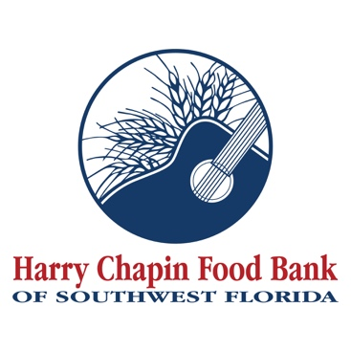

FOR IMMEDIATE RELEASE
DOWNLOAD LINK: PHOTO, LOGO (Credit: Harry Chapin Food Bank)

Harry Chapin Food Bank Receives $10,000 Gift to Support Nutrition Education and Access to Dairy During National Nutrition Month
Fort Myers, Fla. — Harry Chapin Food Bank of Southwest Florida has received a $10,000 gift from Florida Dairy Farmers to support nutrition education and increase access to dairy for neighbors facing food insecurity during National Nutrition Month in March.
The gift supports the Food Bank’s efforts to provide nutritious food and education to children, families, and seniors across Southwest Florida. As the region’s only Feeding America partner food bank, Harry Chapin Food Bank serves more than a quarter of a million people each month through a network of programs and agency partners.
“This partnership helps ensure the food we provide supports long-term health, not just immediate need,” said Richard LeBer, President and CEO of Harry Chapin Food Bank. “Dairy products like milk, yogurt, and cheese are essential sources of nutrients for growing children and older adults, yet they are often among the hardest items for families experiencing food insecurity to afford consistently.”
Access to dairy is a critical issue in hunger relief. National and statewide hunger-relief networks consistently report that dairy products are among the most requested but least donated food items, largely due to cost, refrigeration needs, and limited purchasing power among families facing food insecurity. Milk and other dairy foods provide key nutrients such as calcium, protein, and vitamin D, supporting bone health, muscle development, and overall wellness across the lifespan.
“Dairy plays an important role in supporting health at every stage of life, yet remains a challenge for many families,” said Teresa Moran-Wiebe, Vice President of Health & Wellness at Florida Dairy Farmers. “We’re proud to partner with Harry Chapin Food Bank during National Nutrition Month to help ensure communities across Southwest Florida have access to nutrient-rich foods and nutrition education.”
The timing of the gift aligns with National Nutrition Month, when Harry Chapin Food Bank highlights its Florida Nutrition Education programming. These classes help individuals and families stretch their grocery dollars, prepare healthy meals on a budget, and make informed food choices. Every $10 donated to Harry Chapin Food Bank helps provide the equivalent of 20 meals to neighbors in need.
Harry Chapin Food Bank follows Feeding America’s nutrition guidelines to ensure the food distributed promotes healthier outcomes and improved quality of life for the neighbors it serves. For more information about Harry Chapin Food Bank and its nutrition education efforts, visit harrychapinfoodbank.org.
About Harry Chapin Food Bank
Harry Chapin Food Bank, a Feeding America partner food bank, is the largest hunger-relief organization in Southwest Florida. In 2025, the nonprofit distributed 38.7 million pounds of food through its agency partners, mobile pantries, mobile markets and programs for local children and seniors. The nonprofit serves nearly 300,000 neighbors per month across Charlotte, Collier, Glades, Hendry and Lee counties. Harry Chapin Food Bank is an Agency Partner of United Way, Blueprint Partner of the Naples Children Foundation, rated as a Four-Star Charity by Charity Navigator and Platinum-rated by Candid’s GuideStar. For more information, please visit HarryChapinFoodBank.org or call 239-334-7007.
About Florida Dairy Famers
Florida Dairy Farmers works to strengthen the reputation of dairy as a nutritious and sustainable food while building trust and increasing consumption among consumers. Our organization represents the state’s hardworking dairy farm families who locally produce more than 300 million gallons of fresh milk each year. To learn more about Florida Dairy Farmers, visit FloridaMilk.com.
– END –
Media Contacts:
Irma C. Lancaster, Harry Chapin Food Bank, ILancaster@HCFB.org or 239-334-7007 x103
Dave Breitenstein, Priority Marketing, Dave@PriorityMarketing.com, 239-267-2638 or 239-317-5424 (cell)

