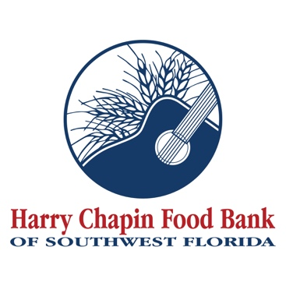

FOR IMMEDIATE RELEASE
DOWNLOAD LINK: PHOTO, LOGO (Credit: Harry Chapin Food Bank)

Gulf Coast Community Foundation helps fight hunger, food insecurity with grant to Harry Chapin Food Bank
Foundation grant supports food distribution programs in Charlotte County
FORT MYERS, Fla. (DATE, 2026) – Harry Chapin Food Bank received a $25,000 grant from Gulf Coast Community Foundation to support hunger-relief efforts in Charlotte County. The grant funding is being provided through the Foundation’s “Area of Greatest Need Fund” to improve access to food for residents of Charlotte County.
Harry Chapin Food Bank, the region’s largest hunger-relief organization and only Feeding America partner food bank, provides food to neighbors experiencing hunger through its agency partners, mobile pantries and mobile markets. In 2025, the Food Bank distributed 5.2 million pounds of food in Charlotte County, the equivalent of 23.27 pounds per resident. Thirty-one of the Food Bank’s agency partners are based in Port Charlotte, Punta Gorda and surrounding communities.
“Charlotte County may be known for its older population, but hunger impacts neighbors of all ages, including retirees, veterans, and families with children,” said Richard LeBer, president and CEO of Harry Chapin Food Bank. “This generous support from Gulf Coast Community Foundation and its supporters will make a meaningful difference by helping put food on the table for neighbors who are facing food insecurity.”
It’s estimated that one in eight Southwest Florida residents – and one in six children – are food insecure.
“Food insecurity touches every part of a community’s wellbeing, and addressing it starts with meeting people where they are,” said Erin Minor, Vice President of Community Leadership at Gulf Coast Community Foundation. “We’re proud to support Harry Chapin Food Bank because access to nutritious food is one of the greatest needs facing our region, and their work meets that need with dignity and care.”

About Harry Chapin Food Bank
Harry Chapin Food Bank, a Feeding America partner food bank, is the largest hunger-relief organization in Southwest Florida. In 2025, the nonprofit distributed 38.7 million pounds of food through its agency partners, mobile pantries, mobile markets and programs for local children and seniors. The nonprofit serves nearly 300,000 neighbors per month across Charlotte, Collier, Glades, Hendry and Lee counties. Harry Chapin Food Bank is an Agency Partner of United Way, Blueprint Partner of the Naples Children Foundation, rated as a Four-Star Charity by Charity Navigator and Platinum-rated by Candid’s GuideStar. For more information, please visit HarryChapinFoodBank.org or call 239-334-7007.
About Gulf Coast Community Foundation
Since 1995, Gulf Coast Community Foundation has powered bold philanthropy and collaborative leadership to drive meaningful change across our region. Guided by values of authenticity, curiosity, collaboration, grit, and a trailblazing spirit, we work side-by-side with donors, partners, and community members to tackle our region’s biggest challenges and unlock its greatest opportunities. Together with our donors, we’ve invested more than $625 million in health and human services, education, civic & economic development, arts & culture, and the environment. Headquartered in Venice, with a second office in downtown Sarasota, Gulf Coast is nationally recognized for excellence, earning multiple “Best Nonprofits to Work For” honors and accreditation from Community Foundations National Standards®. Learn more at GulfCoastCF.org and follow us on Facebook, Instagram, and LinkedIn.
– END –
Media Contacts:
Irma C. Lancaster, Harry Chapin Food Bank, ILancaster@HCFB.org or 239-334-7007 x103
Dave Breitenstein, Priority Marketing, Dave@PriorityMarketing.com, 239-267-2638 or 239-317-5424 (cell)

