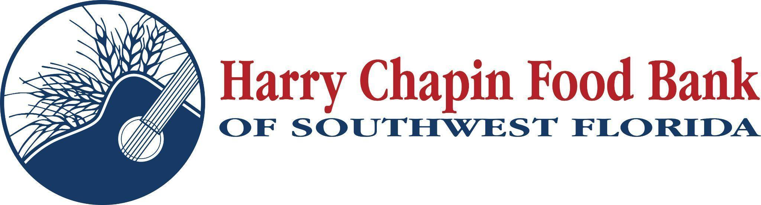
FOR IMMEDIATE RELEASE – PHOTO ATTACHED

FIRST BANK DONATION DRIVE RAISES $38,685 TO SUPPORT HARRY CHAPIN FOOD BANK

FORT MYERS, Fla. (December 22, 2025) – Southwest Florida – First Bank announced today the results of its annual fundraising campaign benefiting Harry Chapin Food Bank, raising a total of $38,685, which will help provide approximately 77,370 meals for children, families, and seniors across Southwest Florida.

Branches across Clewiston, LaBelle, East Fort Myers, Moore Haven, Belle Glade, and Immokalee rallied their staff and communities throughout the campaign, collectively raising $12,895. The Belle Glade branch earned top honors for generating $8,200 of that total. In a major show of support, First Bank matched donations at double the amount, contributing an additional $25,790.

“We are incredibly grateful to First Bank for their dedication to helping families in need,” said Richard LeBer, President and CEO of Harry Chapin Food Bank. “This generous contribution will make a meaningful impact for thousands of our neighbors who are struggling to put food on the table. First Bank has shown what true community partnership looks like, and we deeply appreciate their commitment to fighting hunger across Southwest Florida.”

“I am very pleased with the results of our fundraising drive,” said Andrew Couse, President and CEO of First Bank. “Hats off to our First Bank team for going above and beyond in the effort. I want to thank Harry Chapin; they have been a great partner in this effort. They have been a joy to collaborate with. We fully support their mission to address hunger and food insecurity in Southwest Florida.”

Funds raised will support Harry Chapin Food Bank’s critical programs, including Mobile Pantries, the Care & Share Senior Feeding Program, and the distribution of fresh produce, meat, and shelf-stable foods to more than a quarter million people annually.

About First Bank
First Bank, a community bank since 1922 serving the communities of Clewiston, LaBelle, East Fort Myers, Moore Haven, Belle Glade, and Immokalee. Additional information on First Bank can be found at first1bank.com. Member FDIC.

About Harry Chapin Food Bank
Harry Chapin Food Bank, a Feeding America partner food bank, is the largest hunger-relief organization in Southwest Florida and serves 300,000 neighbors monthly through its Feeding Network of up to 175 agency partners. In 2024, the nonprofit distributed 39.5 million pounds of food, the equivalent of 32 million meals, at food banks and mobile pantries across Charlotte, Collier, Glades, Hendry and Lee counties. The food bank is privately funded and receives support from individuals, businesses, foundations, grocery stores and food distributors. Harry Chapin Food Bank is an Agency Partner of United Way and a Blueprint Partner of the Naples Children Foundation, rated as a Four-Star Charity by Charity Navigator and Platinum-rated by Candid’s GuideStar. For more information, please visit HarryChapinFoodBank.org or call 239-334-7007.

- END-
Media Contacts:
Irma C. Lancaster, Harry Chapin Food Bank, ILancaster@HCFB.org or 239-334-7007 x103
Dave Breitenstein, Priority Marketing, Dave@PriorityMarketing.com, 239-267-2638 or 239-317-5424 (cell)

