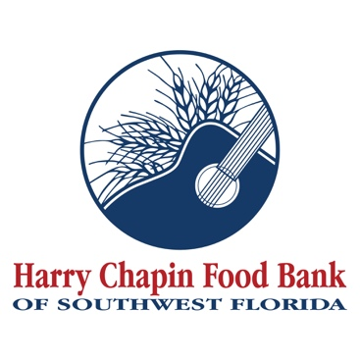

FOR IMMEDIATE RELEASE
DOWNLOAD LINKS (Credit: Harry Chapin Food Bank)
- PHOTOS
- VIDEOS (Broll & Interviews)

Mini-Golf Challenge a hole-in-one for Harry Chapin Food Bank
GL Homes launches Summer of Service with putt-putt competition in Naples
NAPLES, Fla. (June 19, 2026) – GL Homes launched its annual Summer of Service initiative with a $10,000 donation to Harry Chapin Food Bank and a friendly competition designed to raise awareness of hunger in Southwest Florida.
The GL Homes Can-Do Mini-Golf Challenge, which benefited Harry Chapin Food Bank and was hosted June 18 at the nonprofit’s Naples distribution center, pitted two teams of GL Homes employees against each other to design and construct a three-hole putt-putt golf course using cans of green beans and boxes of macaroni and cheese. Teams were required to incorporate a tunnel, ramp, bank shot or hazard into each hole, and judges evaluated course designs based on creativity, best use of food and playability.
“Being a builder, we put people in homes, and the next thing that you need after you have a roof over your head is food in your belly,” said Dianna Betancourt, vice president and project manager for GL Homes. “We work with a lot of charities that house people, and we also work with charities that help feed people. The cans and boxes of food that we used today will be donated to St. Matthew’s House.”
The contribution of food is part of GL Homes’ $10,000 donation to Harry Chapin Food Bank.
The Florida homebuilder’s summer initiative coincides with a period of increased demand for food across Southwest Florida. Hunger is especially challenging during summer months, when families can lose daily access to school-provided breakfasts and lunches. Additionally, many working parents see their hours cut as agriculture and tourism decline before rebounding in the fall.
Harry Chapin Food Bank, which is supported by generous individuals, businesses and foundations, serves 300,000 neighbors monthly through its agency partners, mobile pantries, mobile markets and programs for local children and seniors.
“Everything we do at the Harry Chapin Food Bank is built around partnerships with a variety of people in the community,” said Richard LeBer, president and CEO of Harry Chapin Food Bank. “We certainly never want to say no to someone who wants to write a check and make a donation, but it’s so much more fun, so much more engaging and so much more educational for an organization and its employees if they can engage directly in the work of the food bank. Events like this one create better understanding, better enthusiasm and motivate people so much more.”
The Mini-Golf Challenge was GL Homes’ fourth consecutive year supporting Harry Chapin Food Bank through its Summer of Service. The builder’s philanthropic initiatives support over 100 nonprofits across Florida and beyond, focusing on homelessness, hunger, children and education.
About Harry Chapin Food Bank
Harry Chapin Food Bank, a Feeding America partner food bank, is the largest hunger-relief organization in Southwest Florida. In 2025, the nonprofit distributed 38.7 million pounds of food through its agency partners, mobile pantries, mobile markets and programs for local children and seniors. The nonprofit serves nearly 300,000 neighbors per month across Charlotte, Collier, Glades, Hendry and Lee counties. Harry Chapin Food Bank is an Agency Partner of United Way, Blueprint Partner of the Naples Children Foundation, rated as a Four-Star Charity by Charity Navigator and Platinum-rated by Candid’s GuideStar. For more information, please visit HarryChapinFoodBank.org or call 239-334-7007.
About GL Homes
For 50 years, GL Homes has grown from a small, local home builder to one of the nation’s largest. GL Homes has created exceptional communities and built quality homes in Florida's most desirable locations including Collier, Lee, Hillsborough, Pasco, Palm Beach, Broward, Indian River and St. Lucie Counties. www.glhomes.com and www.glhomesphilanthropy.com.
– END –
Media Contacts:
Irma C. Lancaster, Harry Chapin Food Bank: ILancaster@HCFB.org or 239-334-7007 x103
Dave Breitenstein, Priority Marketing: Dave@PriorityMarketing.com, 239-267-2638 or 239-317-5424 (cell)

