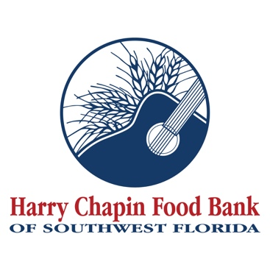

FOR IMMEDIATE RELEASE
PHOTO

Harry Chapin Food Bank names longtime leader Jennifer Denike Chief Development Officer
FORT MYERS, Fla. (DATE, 2026) – Harry Chapin Food Bank of Southwest Florida has named Jennifer Denike as its new Chief Development Officer, strengthening the organization’s leadership team at a time of continued growth and rising demand across the region.
Denike has more than 18 years of nonprofit fundraising and relationship management experience, with a proven track record of building strong donor partnerships and driving revenue growth. Throughout her career, she has supported the cultivation of hundreds of major donors and helped generate more than $9 million in philanthropic revenue, including significant contributions to Harry Chapin Food Bank, Florida Gulf Coast University, and Florida Repertory Theatre.
Denike has been part of the Harry Chapin Food Bank team for the past several years, most recently serving as Senior Major Gifts Officer after previously holding the role of Major Gifts Officer. During her time with the organization, she has played a key role in strengthening donor relationships, expanding major gift strategies, and supporting the food bank’s continued growth in serving neighbors across Southwest Florida.
She has deep roots in Southwest Florida and has been actively involved in the community since relocating to the region in 2015. She serves on the board of the Planned Giving Council of Lee County, is a member of the Association of Fundraising Professionals Collier-Lee Chapter, and was recognized as a Gulfshore Business 40 Under 40 honoree. She is also a graduate of Leadership SWFL and completed the Southwest Florida Leadership Institute at Florida Gulf Coast University in 2025. Denike holds a Bachelor of Arts in Psychology from the State University of New York at Cortland.
As Chief Development Officer, Denike will serve as a member of the senior leadership team, leading fundraising strategies, donor engagement, and revenue growth initiatives. She will oversee major gifts, corporate and foundation partnerships, grants, and donor stewardship efforts, while helping guide long-term fundraising planning. Denike will also lead efforts supporting the capital campaign for the new Hunger Action Center in Fort Myers and future expansion plans for a new facility in Naples.
“I am honored to step into the role of Chief Development Officer at Harry Chapin Food Bank during such a pivotal time,” said Denike. “As we look ahead to significant growth and investment in our community, I am committed to strengthening relationships, elevating our mission, and ensuring we have the resources needed to serve more neighbors across Southwest Florida.”
“Jennifer understands our mission, our community, and what it takes to move this work forward,” said Richard LeBer, President and CEO of Harry Chapin Food Bank. “Her leadership and experience within our organization position us to strengthen our donor partnerships and expand the resources needed to meet the growing demand across Southwest Florida.”
Denike will officially step into the role of Chief Development Officer on April 6, 2026. For more information or to support the mission, visit harrychapinfoodbank.org.
About Harry Chapin Food Bank
Harry Chapin Food Bank, a Feeding America partner food bank, is the largest hunger-relief organization in Southwest Florida. In 2025, the nonprofit distributed 38.7 million pounds of food through its agency partners, mobile pantries, mobile markets and programs for local children and seniors. The nonprofit serves nearly 300,000 neighbors per month across Charlotte, Collier, Glades, Hendry and Lee counties. Harry Chapin Food Bank is an Agency Partner of United Way, Blueprint Partner of the Naples Children Foundation, rated as a Four-Star Charity by Charity Navigator and Platinum-rated by Candid’s GuideStar. For more information, please visit HarryChapinFoodBank.org or call 239-334-7007.

– END –
Media Contacts:
Irma C. Lancaster, Harry Chapin Food Bank, ILancaster@HCFB.org or 239-334-7007 x103
Dave Breitenstein, Priority Marketing, Dave@PriorityMarketing.com, 239-267-2638 or 239-317-5424 (cell)

