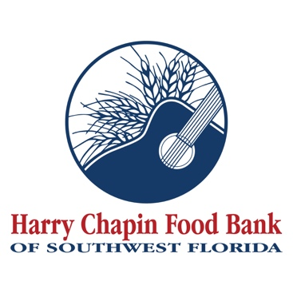

FOR IMMEDIATE RELEASE
DOWNLOAD LINK: PHOTO, LOGO (Credit: Harry Chapin Food Bank)

Harry Chapin Food Bank of Southwest Florida receives $30,000 Jingled Elves grant to support children in Immokalee
Immokalee, FL (DATE) – Harry Chapin Food Bank of Southwest Florida announced that it has received a $30,000 grant from Jingled Elves, Inc., a nonprofit organization dedicated to improving the lives of women and children in Collier County.
The grant will support Harry’s Helpings, a child-focused feeding program that provides supplemental food kits to families at childcare, early education, and after-school sites where traditional food pantry access may be limited. Each kit includes nutritious, shelf-stable food designed to help support families between regular meals.
Funding from the Jingled Elves grant will be used to support weekly food kits distributed through the Boys and Girls Club in Immokalee, helping ensure children and their families have reliable access to food throughout the week. As part of the grant agreement, each kit will include a custom Jingled Elves sticker recognizing the organization’s commitment to helping end child hunger.
“At Jingled Elves, our mission is to improve the lives of women and children in Collier County, and that begins with ensuring children have access to nutritious food,” said Donna Issenmann, Founder and President of Jingled Elves. “We are proud to support Harry Chapin Food Bank’s Harry’s Helpings program and its work to reach children in Immokalee, where consistent access to food can make a meaningful difference for families.”
“We are grateful to Jingled Elves for their support of children and families in Immokalee,” said Richard LeBer, president and CEO of Harry Chapin Food Bank of Southwest Florida. “Harry’s Helpings allows us to reach children in settings where food access can be a challenge, and this funding will help strengthen our ability to support families who need it most.”
This investment reflects a shared commitment to supporting children and families in Immokalee. By working together, Harry Chapin Food Bank of Southwest Florida and Jingled Elves are helping ensure that food assistance reaches children where it is needed most.
About Harry Chapin Food Bank
Harry Chapin Food Bank, a Feeding America partner food bank, is the largest hunger-relief organization in Southwest Florida. In 2025, the nonprofit distributed 38.7 million pounds of food through its agency partners, mobile pantries, mobile markets and programs for local children and seniors. The nonprofit serves nearly 300,000 neighbors per month across Charlotte, Collier, Glades, Hendry and Lee counties. Harry Chapin Food Bank is an Agency Partner of United Way, Blueprint Partner of the Naples Children Foundation, rated as a Four-Star Charity by Charity Navigator and Platinum-rated by Candid’s GuideStar. For more information, please visit HarryChapinFoodBank.org or call 239-334-7007.
About Jingled Elves
Jingled Elves, Inc. is a 501(c)(3) nonprofit organization providing grants to charitable organizations focused on improving the lives of women and children in Collier County, Florida. Since our founding in 2017 we have provided a total of $1,080,000 in grants to local nonprofits. We raise funds through our annual Jingled Elves Trolley Tour, sponsorships, shop and share events with retail partners, annual bingo party and donations.
– END –
Media Contacts:
Irma C. Lancaster, Harry Chapin Food Bank, ILancaster@HCFB.org or 239-334-7007 x103
Dave Breitenstein, Priority Marketing, Dave@PriorityMarketing.com, 239-267-2638 or 239-317-5424 (cell)

