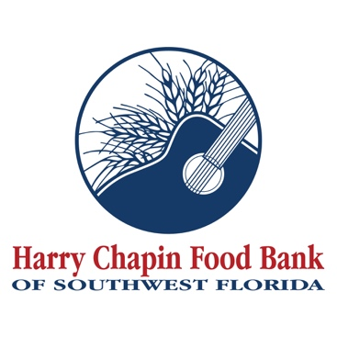

FOR IMMEDIATE RELEASE
PHOTO ATTACHED (Credit: Harry Chapin Food Bank)

Naples Children Foundation invests $1.2 million in Harry Chapin Food Bank to strengthen child hunger programs in Collier County
NAPLES, Fla. (July 22, 2026) – Harry Chapin Food Bank of Southwest Florida has been awarded a $1.2 million grant from Naples Children Foundation, founders of the Naples Winter Wine Festival, to strengthen programs that help children and families in Collier County access nutritious food.
As a Blueprint Partner in NCF's Hunger Initiative, Harry Chapin Food Bank plays a role in coordinating a collaborative network of nonprofit partners working together to reduce childhood hunger and improve food security throughout the community. The strategic partnership will support the Food Bank's child hunger initiatives through June 2028.
The award is part of the Naples Children Foundation's recent investment of $30.6 million in strategic grants benefiting nonprofit organizations serving children throughout Collier County. The funding will help Harry Chapin Food Bank expand its work with schools, early learning centers, after-school programs and other trusted partners to provide food assistance when children need it most.
"We are grateful to the Naples Children Foundation for its partnership and commitment to children in our community," said Richard LeBer, president and CEO of Harry Chapin Food Bank. "For many families, putting healthy food on the table remains a daily challenge. Together, we are helping ensure more children have consistent access to nutritious food, creating a stronger foundation for healthier lives and brighter futures."
"No child should have to wonder where their next meal is coming from,” said Maria Jimenez-Lara, CEO of the Naples Children Foundation. “At NCF, we believe lasting change happens when organizations work together toward a shared goal. Addressing childhood hunger requires far more than providing meals – it requires building a coordinated system of care that ensures children and families have consistent access to nutritious food. Through our Hunger Initiative, we invest in collaborative solutions that strengthen the network of organizations addressing childhood hunger. As our Blueprint Partner, Harry Chapin Food Bank plays a critical leadership role in that effort, helping ensure more children and families have reliable access to nutritious food and the support they need to thrive."
Through initiatives such as school-based programs and take-home food assistance, Harry Chapin Food Bank helps bridge the gap during evenings, weekends, school breaks and other times when children may have limited access to nutritious meals. This investment will strengthen those efforts and help more children receive the nourishment they need to learn, grow and thrive.
About the Harry Chapin Food Bank
Harry Chapin Food Bank, a Feeding America partner food bank, is the largest hunger-relief organization in Southwest Florida. In 2025, the nonprofit distributed 38.7 million pounds of food through its agency partners, mobile pantries, mobile markets and programs for local children and seniors. The nonprofit serves nearly 300,000 neighbors per month across Charlotte, Collier, Glades, Hendry and Lee counties. Harry Chapin Food Bank is an Agency Partner of United Way, Blueprint Partner of the Naples Children Foundation, rated as a Four-Star Charity by Charity Navigator and Platinum-rated by Candid’s GuideStar. For more information, please visit HarryChapinFoodBank.org or call 239-334-7007.
About Naples Children Foundation
The Naples Children Foundation, the founding organization of the Naples Winter Wine Festival, creates transformational change and improves educational, emotional and health outcomes for vulnerable children in Collier County. Through its annual grants and strategic initiatives, NCF has impacted nearly 90 of the most effective nonprofits in the local community, providing 420,000 children with the services and resources they need to succeed. Through bold investments, collaborative partnerships, and data-driven solutions, NCF supports programs that ensure every child can thrive. NCF’s unique approach, which bridges public and private resources, has become a blueprint for how to transform a community – one issue at a time.
– END –
Media Contacts:
Irma C. Lancaster, Harry Chapin Food Bank, ILancaster@HCFB.org or 239-334-7007 x103
Dave Breitenstein, Priority Marketing, Dave@PriorityMarketing.com, 239-267-2638 or 239-317-5424 (cell)

