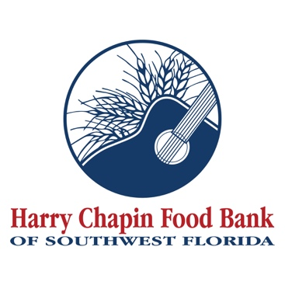

FOR IMMEDIATE RELEASE
PHOTO ATTACHED (Credit: Harry Chapin Food Bank)

Harry Chapin Food Bank receives Fly Beyond Key Issue Grant from The Wawa Foundation to fight hunger and inspire goodness with food
FORT MYERS, Fla. (Aug. 4, 2026) – Harry Chapin Food Bank has received a $15,000 Fly Beyond Key Issue Grant from The Wawa Foundation to help provide children and families across Southwest Florida with increased access to nutritious food through its In-School Pantry Program.
“We are grateful to The Wawa Foundation for its investment in children and families across Southwest Florida,” said Richard LeBer, president and CEO of Harry Chapin Food Bank. “This grant will strengthen our In-School Pantry Program, helping us provide nutritious food in trusted school settings where children and families can access the support they need.”
The Wawa Foundation's Fly Beyond Key Issue Grants typically range between $5,000 and $250,000 and are awarded to qualified partners with existing or new programs that align with the Fly Beyond mission. In total, The Wawa Foundation is awarding $1.5 million to 38 Feeding America food bank partners as part of its signature initiative to increase access to fresh, nutritious meals for youth and families.
As a nonprofit community partner of The Wawa Foundation, a Feeding America food bank and Check-Out Hunger partner, Harry Chapin Food Bank applied for a Fly Beyond Key Issue Grant this spring. The Wawa Foundation reviewed proposals and awarded grants based on alignment with Fly Beyond criteria and goals, program reach and impact, and the size of the Wawa market served.
“In its fourth year, the Fly Beyond Key Issue Grant program remains a strong driver in addressing food insecurity, with an emphasis on helping youth develop healthy habits through reliable access to nutritious meals and snacks,” said Liz Simeone, president of The Wawa Foundation. “We’re proud to support 38 food banks this year, including Harry Chapin Food Bank, and the meaningful work they’re doing to advance this important mission.”
Harry Chapin Food Bank's In-School Pantry Program helps remove barriers to food access by bringing nutritious food directly to schools, allowing children and their families to receive groceries in a familiar and trusted environment. Working with more than 50 schools across Charlotte, Collier, Glades, Hendry and Lee counties, the program provides shelf-stable staples and, when available, fresh and frozen foods, helping students arrive at school nourished and ready to learn.
About Wawa and The Wawa Foundation Fly Beyond Programs
Launched in 2023 with initial partner Second Harvest Food Bank of Central Florida, Fly Beyond programs are supported by Wawa and The Wawa Foundation with the goal of fighting food insecurity at the community level. They are designed to inspire goodness and increase access to fresh, nutritious food and healthy meals for youth through Wawa's Feeding America food bank partners. Fly Beyond connects all programs focused on this core issue to enable measurements, foster communication, and drive solutions.
About The Wawa Foundation
The Wawa Foundation is an extension of Wawa's commitment to making the world a better place by fulfilling customers' lives every day. The Wawa Foundation is a registered 501(c)(3) nonprofit corporation founded by Wawa, Inc. to support the company's charitable giving and philanthropic activities, ultimately helping build happier, stronger communities. The Wawa Foundation focuses its support on organizations committed to health, hunger, and everyday heroes through local, regional, and national grants and in-kind donations. Since 2014, Wawa and The Wawa Foundation have donated more than $215 million to causes supporting health, hunger, and the heroes who serve our communities every day.
About the Harry Chapin Food Bank
Harry Chapin Food Bank, a Feeding America partner food bank, is the largest hunger-relief organization in Southwest Florida. In 2025, the nonprofit distributed 38.7 million pounds of food through its agency partners, mobile pantries, mobile markets and programs for local children and seniors. The nonprofit serves nearly 300,000 neighbors per month across Charlotte, Collier, Glades, Hendry and Lee counties. Harry Chapin Food Bank is an Agency Partner of United Way, Blueprint Partner of the Naples Children Foundation, rated as a Four-Star Charity by Charity Navigator and Platinum-rated by Candid’s GuideStar. For more information, please visit HarryChapinFoodBank.org or call 239-334-7007.
– END –
Media Contacts:
Irma C. Lancaster, Harry Chapin Food Bank, ILancaster@HCFB.org or 239-334-7007 x103
Dave Breitenstein, Priority Marketing, Dave@PriorityMarketing.com, 239-267-2638 or 239-317-5424 (cell)

